Global healthcare systems are dealing with never-before-seen issues, such as aging populations and the burden of chronic diseases, in addition to rising prices and unequal access to care. Technological developments provide a glimmer of hope for improving healthcare management and delivery despite these obstacles. The combination of cloud computing and the Internet of Things (IoT) is one of these technologies that is most powerfully fostering innovation and transforming healthcare systems around the world. The status of healthcare systems around the world now emphasizes how urgently creative solutions are needed to address the problems that affect patients, healthcare professionals, and legislators equally. The delivery of healthcare is still fragmented, inefficient, and frequently inaccessible to vast sectors of the population, despite tremendous advancements in medical research and therapies. These issues are made worse by escalating expenses, an aging population, and the prevalence of chronic illnesses, underscoring the necessity of revolutionary change. The integration of IoT and cloud computing sits at the core of this change. Because of its affordability, scalability, and flexibility, cloud computing offers healthcare systems a strong platform for updating their procedures and infrastructure. Healthcare companies may easily store, handle, and analyze enormous volumes of data produced by IoT devices by utilizing cloud infrastructure. This opens up new opportunities for enhancing patient care and results. The Internet of Things (IoT), meanwhile, has revolutionized the way healthcare is delivered and managed. From wearable devices that monitor vital signs in real-time to smart medical equipment that automates data collection and analysis, IoT technologies empower patients and healthcare providers with unprecedented insights into health metrics and conditions. By integrating with cloud infrastructure, IoT devices can transmit data to centralized databases for storage, analysis, and interpretation, enabling proactive healthcare management and personalized medicine initiatives. It is crucial to comprehend the underlying ideas and concepts of cloud computing and the Internet of Things as we set out to transform healthcare systems using these technologies. This chapter will cover the essential elements of cloud computing and IoT in the healthcare industry, looking at their uses, advantages, and difficulties. We can more fully recognize the transformative potential of these technologies if we have a greater understanding of them and how they affect the administration and delivery of healthcare.We will clarify how cloud computing and IoT are fostering innovation in healthcare through a thorough examination of current trends, case studies, and future projections. We will examine the various ways that these technologies are transforming healthcare delivery, from bettering patient tracking and monitoring to raising the caliber of diagnosis and treatment results. Additionally, we will look at the difficulties and factors to take into account when integrating cloud computing and IoT in the healthcare industry, providing advice and solutions for overcoming these difficulties. In summary, the convergence of IoT and cloud computing signifies a paradigm shift in the healthcare industry, presenting hitherto unseen chances to transform patient care, operational effectiveness, and healthcare results. We can create a healthcare system that is more connected, effective, and patient-centric than ever before by embracing these technologies and realizing their full potential. This will pave the way for a healthier and more equitable future for everybody.

| **Chapter** | **Title** |
| --- | --- |
| 1 | Introduction |
| 2 | Understanding Cloud Computing in Healthcare |
| 3 | Exploring the Role of IoT in Healthcare |
| 4 | Integration of Cloud Computing and IoT in Healthcare |
| 5 | Challenges and Considerations |
| 6 | Future Directions and Opportunities |
| 7 | Conclusion |
| 8 | References |

This chapter examines how cloud computing and the Internet of Things interact and how this has a significant impact on healthcare systems. We explore these technologies' revolutionary potential, looking at how they are changing patient care, increasing operational effectiveness, and spurring innovation in the provision of healthcare.

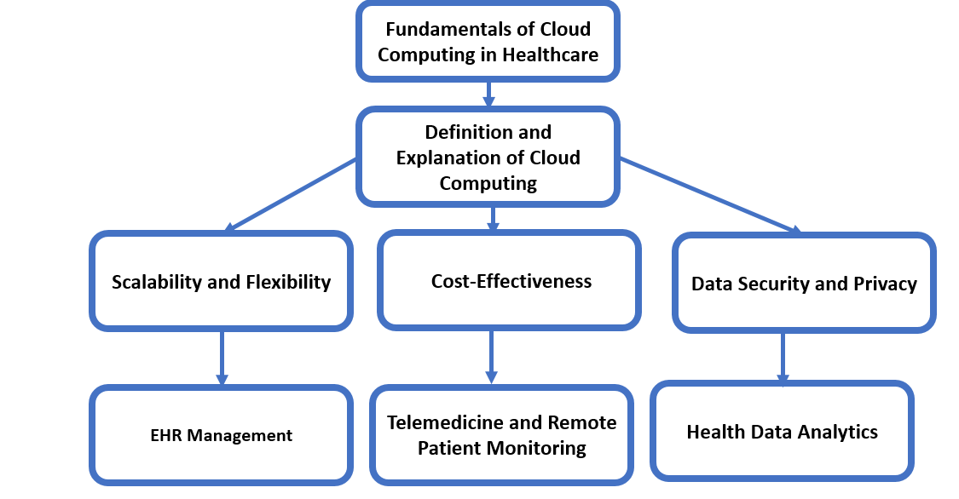Rapid technological breakthroughs are causing a paradigm shift in the healthcare industry. In the connected world of today, creative solutions driven by cloud computing and the Internet of Things (IoT) are reshaping and reimagining established healthcare delivery methods. Global healthcare systems are dealing with never-before-seen difficulties. The delivery of healthcare is still fragmented, inefficient, and frequently inaccessible to vast sectors of the population, despite tremendous advancements in medical research and therapies. The burden of chronic illnesses, unequal access to care, and growing expenses all highlight the pressing need for creative solutions to enhance the quality and efficiency of healthcare. Next consider cloud computing and the Internet of Things (IoT), two cornerstones of the digital revolution that are transforming global industries. Cloud computing provides internet-based, scalable, and on-demand access to computational resources. In contrast, the Internet of Things (IoT) consists of networked devices and sensors that gather, transfer, and process data instantly. When combined, these technologies have the potential to revolutionize the way healthcare is delivered by improving accessibility, effectiveness, and quality of care. The purpose of this chapter is to examine how cloud computing and IoT can revolutionize healthcare systems. We'll examine how these technologies are changing the healthcare scene through a thorough examination of recent trends, case studies, and future estimates. Through our analysis of the potential benefits, obstacles, and ramifications of their integration, we hope to enlighten and motivate stakeholders in the healthcare system. We will explore the applications, synergies, and disruptive possibilities of cloud computing and IoT in healthcare as we go deeper into the next topics. Readers will have a better grasp of how these technologies are spurring innovation and laying the groundwork for a healthcare system that is more connected, effective, and patient-centred by the end of the chapter. Global healthcare systems are dealing with never-before-seen difficulties. The delivery of healthcare is still fragmented, inefficient, and frequently inaccessible to vast sectors of the population, despite tremendous advancements in medical research and therapies. The burden of chronic illnesses, unequal access to care, and rising expenses highlight the pressing need for creative ideas to enhance healthcare delivery and results. These problems demand that existing healthcare models be reassessed and that cutting-edge technologies be implemented to improve effectiveness, accessibility, and care quality. The purpose of this chapter is to examine how cloud computing and IoT can revolutionize healthcare systems. We'll examine how these technologies are changing the healthcare scene through a thorough examination of recent trends, case studies, and future estimates. Through our analysis of the potential benefits, obstacles, and ramifications of their integration, we hope to enlighten and motivate stakeholders in the healthcare system. We will explore the applications, synergies, and disruptive possibilities of cloud computing and IoT in healthcare as we go deeper into the next topics. Readers will have a better grasp of how these technologies are spurring innovation and laying the groundwork for a healthcare system that is more connected, effective, and patient-centred by the end of the chapter.

**Leveraging Cloud Computing: Using Scalability and Innovation to Revolutionize Healthcare Delivery and Management**   
Cloud computing is essential for upgrading healthcare systems because it solves important issues including data security, cost-effectiveness, and scalability. Cloud computing provides scalability to the healthcare industry by enabling firms to dynamically modify their computer resources based on demand, particularly in an industry where the volume of data collected is always expanding. This guarantees that healthcare systems are able to effectively manage workload variations, for example, during periods of high patient care or when processing sizable datasets for scientific analysis. Furthermore, cloud computing lowers the expense of maintaining infrastructure and data centers located on-site. By utilizing pay-as-you-go cloud services, healthcare organizations may optimize their IT budgets and redirect revenues towards patient care and innovation. They only pay for the resources that they utilize. In addition, cloud computing service providers follow laws like HIPAA by putting strict security measures in place to protect private patient information. Healthcare institutions can reduce security concerns and concentrate on providing high-quality patient care by giving trustworthy cloud service providers control over data management. Cloud computing is transforming telemedicine, health data analytics, Electronic Health Records (EHR) management, and other facets of healthcare delivery. Healthcare practitioners may securely store, access, and exchange patient records in real time from any place with cloud-based EHR systems. This guarantees healthcare providers have access to current medical information, which promotes coordinated treatment and enhances patient outcomes. Cloud-hosted telemedicine services facilitate remote consultations between patients and healthcare practitioners, thereby removing geographic barriers to care and enhancing accessibility for marginalized and rural groups. Additionally, cloud-based health data analytics tools enable healthcare companies to track disease outbreaks, identify patterns, and make well-informed decisions to enhance population health from massive datasets. All things considered, these illustrations show how cloud computing has revolutionized healthcare delivery, improving effectiveness, accessibility, and care quality.

**Leading IoT Solutions: Transforming Healthcare Administration and Delivery**

Examining IoT's Potential Use in Healthcare ,A new era of connectedness and intelligence is being ushered in by the integration of the Internet of Things (IoT) in healthcare, which presents revolutionary opportunities to improve patient care, maximize resource use, and completely change the way healthcare is delivered. In this section, we go more deeply into the core ideas of IoT in healthcare, explaining its importance and looking at a wide range of applications in different areas of the healthcare ecosystem. An explanation of IoT in healthcare, a definition   
The Internet of Things, or IoT, is essentially a network of networked sensors, devices, and systems that collect, transfer, and analyze data in real-time. IoT devices are widely used in the healthcare industry. They include smart medical equipment, wearable health trackers, advanced remote monitoring systems, and ambient-assisted living technologies. The seamless connectivity and data interchange made possible by these networked devices allows healthcare providers to monitor patients from a distance, make preventive interventions, and customize care depending on each patient's requirements and preferences. The implementation of IoT in healthcare signifies a fundamental change in the way patient care is provided and overseen. Healthcare professionals can virtually monitor patients' vital signs, medication adherence, and disease development remotely from any place thanks to the real-time monitoring and tracking capabilities provided by IoT devices. This makes it possible to identify health problems early, take action quickly, and create individualized treatment regimens that are catered to the particular needs of each patient. IoT also improves operational efficiency in healthcare businesses by automating repetitive processes, optimizing resource use, and lowering healthcare expenditures related to ER visits and hospital readmissions. The Internet of Things has several and significant uses in the healthcare industry, including remote patient monitoring, managing chronic diseases, and creating smart healthcare facilities. Fitness trackers and smartwatches are examples of wearable health technology that enable people to track their heart rate, sleep habits, and physical activity in real-time, encouraging a proactive approach to wellness and health management. Similarly, patients can monitor their vital signs at home and easily exchange data with healthcare practitioners for remote monitoring and management of chronic illnesses thanks to smart medical devices like blood pressure cuffs and connected glucose monitors. Additionally, IoT makes it easier to design intelligent healthcare facilities that are furnished with cutting-edge technology like predictive maintenance programs, environmental monitoring sensors, and asset tracking systems. Through maintaining ideal environmental conditions, proactively identifying and resolving maintenance issues before they worsen, and guaranteeing the availability of medical equipment, these technologies optimize hospital processes, improve patient safety, and improve the overall patient experience. Organizations in the healthcare industry can seize previously unheard-of chances for innovation, efficiency, and patient-centered care delivery by utilizing the Internet of Things. The advantages of cloud computing and IoT will be discussed in the section that follows, along with

how their combination might improve the performance and capacities of healthcare systems.

**Optimizing Healthcare Potential: The Meeting Point of IoT Integration and Cloud Computing**

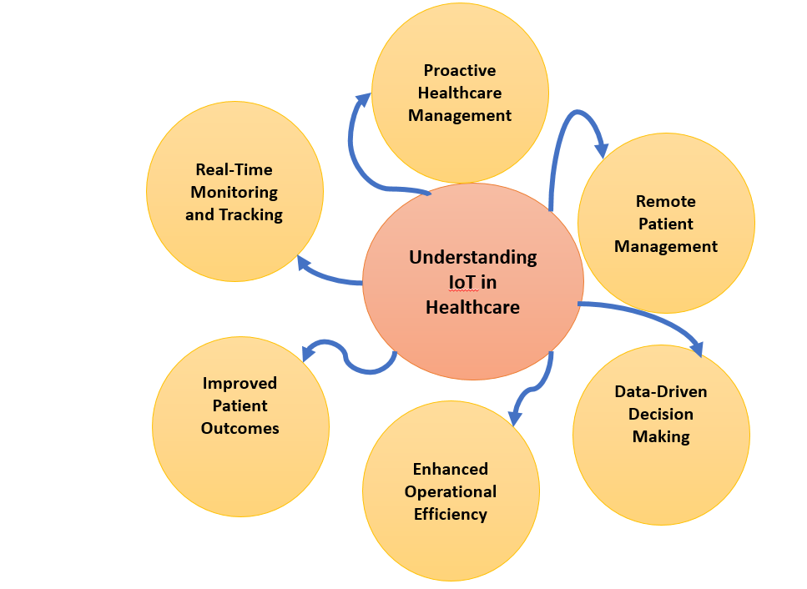The convergence of cloud computing and the Internet of Things (IoT) has the potential to revolutionize the healthcare industry by combining powerful capabilities that can spur innovation and enhance patient outcomes. This section explores the complex interactions between these two revolutionary technologies, explaining how their combination works in concert to completely change the way healthcare is managed and delivered. The symbiotic relationship that enhances the capabilities of both technologies is at the core of the integration of cloud computing with IoT. The scalable infrastructure required to handle the enormous volume of data produced by Internet of Things devices is provided by cloud computing. Healthcare companies can store, handle, and analyze enormous volumes of data created by the Internet of Things (IoT) with unmatched flexibility and efficiency by utilizing cloud-based resources. In addition, the cloud makes it easier to connect and be accessible, allowing users to access data and insights instantly from anywhere at any time. The core technology supporting the efficacy and functionality of IoT solutions in the healthcare industry is cloud computing. IoT devices can send data safely and effectively thanks to the cloud's dependable connectivity and scalable architecture, which also ensures consistent communication between systems and devices. Furthermore, cloud platforms enable healthcare businesses to extract meaningful insights from IoT data through advanced data analytics and machine learning capabilities. These insights help to make well-informed decisions, make predictive analytics possible for early intervention, and make it easier to provide patients with individualized care. Numerous case studies demonstrate how cloud computing and IoT may be successfully integrated in healthcare environments. Healthcare practitioners can monitor patients' vital signs, medication adherence, and illness development in real-time with remote patient monitoring systems that are powered by Internet of Things (IoT) sensors and devices. This can result in better patient outcomes and fewer hospital readmissions. In a similar vein, cloud-hosted telemedicine technologies with IoT capabilities offer remote consultations and care delivery, increasing patient satisfaction and increasing access to healthcare services. In conclusion, there is a great deal of potential for the healthcare industry to change patient care management and delivery through the integration of cloud computing and IoT. Healthcare companies may increase operational effectiveness, foster new avenues for innovation, and ultimately improve the standard of patient care by utilizing the synergies between these technologies.

**Overcoming Obstacles and Taking Into Accounts when Implementing IoT and Cloud Computing in Healthcare**

The potential for transforming patient care delivery and management is enormous when cloud computing and the Internet of Things (IoT) are combined with the healthcare industry. To ensure that these technologies are successfully adopted and used in healthcare settings, however, the installation of these technologies also brings special obstacles and considerations that need to be carefully addressed. This section offers a thorough analysis of the challenges and important elements that healthcare organizations need to overcome in order to fully reap the rewards of cloud computing and IoT in terms of bettering patient outcomes and increasing operational effectiveness. Privacy and security issues are a major barrier to the adoption of cloud computing and IoT in the healthcare industry. If not sufficiently protected, the enormous volume of private patient data created and transferred by IoT devices presents serious concerns. To protect patient information and maintain compliance with laws like the Health Insurance Portability and Accountability Act (HIPAA), healthcare institutions must put strong security measures in place, such as data encryption, access controls, and frequent security audits. To reduce the chance of data breaches and illegal access, cloud service providers also have to abide by strict security requirements and procedures. Another essential aspect to take into account when integrating cloud computing and IoT in the healthcare industry is interoperability. Data integration and exchange are made more difficult by the wide range of IoT systems and devices that are utilized in healthcare settings, many of which operate on distinct protocols and standards. Healthcare companies need to make investments in technologies and solutions that allow data exchange and smooth communication between various systems. In addition, industry-wide frameworks and standards for interoperability and data interchange are necessary to promote cooperation and information sharing amongst stakeholders in the healthcare system. In the healthcare industry, where continuous access to vital systems and data is necessary for the provision of patient care, reliability and uptime are crucial factors. In order to guarantee uninterrupted operations and reduce downtime, cloud computing and IoT solutions need to exhibit superior dependability and accessibility. To achieve the strict uptime needs of healthcare environments, healthcare businesses must collaborate with trustworthy cloud service providers that offer strong infrastructure, redundant systems, and dependable network connectivity. Proactive monitoring and maintenance techniques are also required to spot such problems early on and fix them before they have an influence on the quality of patient care. The ethical implications of using patient data are becoming more and more important when it comes to cloud computing and the Internet of Things in the healthcare industry. In order to ensure transparent data collecting, utilization, and sharing methods, healthcare institutions must place a high priority on patient privacy and autonomy. To provide patients the power to manage their health information and make knowledgeable decisions about its use, frameworks for data governance and consent procedures should be put in place. In order to maintain patient trust and confidence, healthcare practitioners must also abide by ethical rules and principles, such as beneficence, non-maleficence, and respect for patient autonomy, when developing and implementing cloud computing and Internet of Things solutions.

**Future Prospects: Combining IoT, AI, ML, and Cloud Computing for Transformative Healthcare Innovation**

The opportunity for transforming patient care delivery and management is enormous when cloud computing and the Internet of Things (IoT) are combined with the healthcare industry. To ensure that these technologies are successfully adopted and used in healthcare settings, however, the installation of these technologies also brings special obstacles and considerations that need to be carefully addressed. This section offers a thorough analysis of the challenges and important elements that healthcare organizations need to overcome in order to fully reap the rewards of cloud computing and IoT in terms of bettering patient outcomes and increasing operational effectiveness. Privacy and security issues are a major barrier to the adoption of cloud computing and IoT in the healthcare industry. If not sufficiently protected, the enormous volume of private patient data created and transferred by IoT devices presents serious concerns. To protect patient information and maintain compliance with laws like the Health Insurance Portability and Accountability Act (HIPAA), healthcare institutions must put strong security measures in place, such as data encryption, access controls, and frequent security audits. To reduce the chance of data breaches and illegal access, cloud service providers also have to abide by strict security requirements and procedures. Another important factor to take into account when integrating 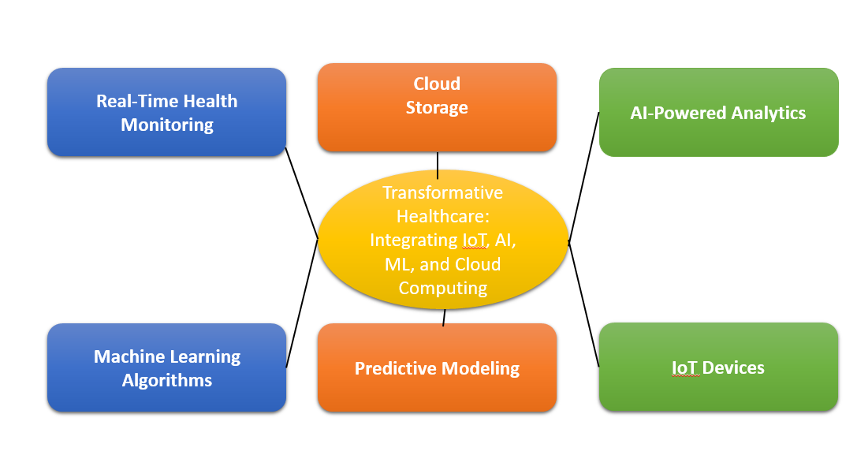cloud computing and IoT in the healthcare industry is interoperability. Data integration and exchange are made more difficult by the wide range of IoT systems and devices that are utilized in healthcare settings, many of which operate on distinct protocols and standards. Healthcare companies need to make investments in technologies and solutions that allow data exchange and smooth communication between various systems. In addition, industry-wide frameworks and standards for interoperability and data interchange are necessary to promote cooperation and information sharing amongst stakeholders in the healthcare system. In the healthcare industry, where continuous access to vital systems and data is necessary for the provision of patient care, reliability and uptime are crucial factors. In order to guarantee uninterrupted operations and reduce downtime, cloud computing and IoT solutions need to exhibit superior dependability and accessibility. To achieve the strict uptime needs of healthcare environments, healthcare businesses must collaborate with trustworthy cloud service providers that offer strong infrastructure, redundant systems, and dependable network connectivity. Proactive monitoring and maintenance techniques are also required to spot such problems early on and fix them before they have an influence on the quality of patient care. The ethical implications of using patient data are becoming more and more important when it comes to cloud computing and the Internet of Things in the healthcare industry. In order to ensure transparent data collecting, utilization, and sharing methods, healthcare institutions must place a high priority on patient privacy and autonomy. To provide patients the power to manage their health information and make knowledgeable decisions about its use, frameworks for data governance and consent procedures should be put in place. In order to maintain patient trust and confidence, healthcare practitioners must also abide by ethical rules and principles, such as beneficence, non-maleficence, and respect for patient autonomy, when developing and implementing cloud computing and Internet of Things solutions. In summary, to fully realize the potential of cloud computing and IoT in enhancing patient care delivery and management, it is imperative to tackle the obstacles and factors involved in their deployment within the healthcare industry. Healthcare businesses may optimize the advantages of cloud computing and IoT while guaranteeing patient safety, privacy, and trust by proactively addressing privacy and security concerns, interoperability challenges, reliability and uptime requirements, and ethical considerations. Future developments in cloud computing, IoT, AI, and ML will lead to major improvements in healthcare administration and delivery. It is reasonable to anticipate an increase in the number of "smart hospitals," which are facilities where technologies and networks are networked together to provide seamless, effective patient care. Treatment regimens that are based on each patient's unique genetic profile, lifestyle, and medical records will proliferate in the field of personalized medicine. Patients will benefit from increased convenience and access to healthcare services no matter where they live because to the growth of telehealth and remote care. Through immersive and interactive experiences, the combination of cloud and IoT technologies with virtual reality (VR) and augmented reality (AR) will improve surgery planning, patient education, and medical training.

**Benefits of IoT and Cloud Computing Integration in Healthcare**

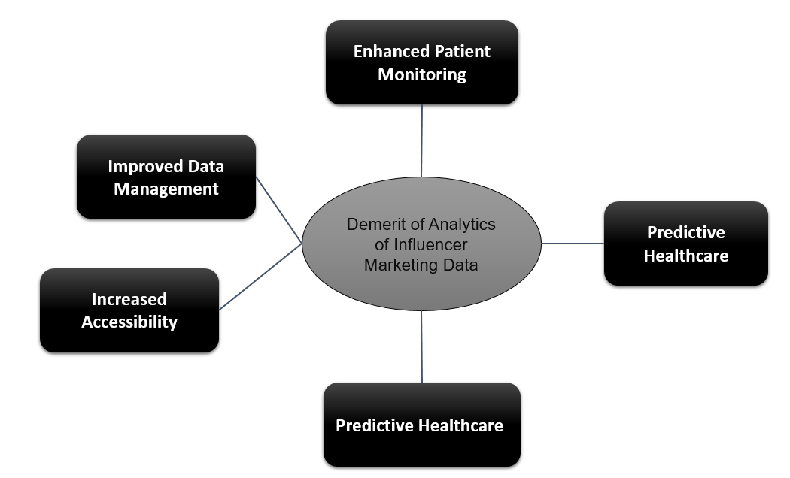There are several benefits to integrating cloud computing and the Internet of Things (IoT) in healthcare, all of which improve patient care, operational effectiveness, and healthcare delivery. The main advantages that these technologies offer the healthcare industry are described in this section. Real-Time Monitoring and Early Intervention: Internet of Things (IoT) devices allow for the continuous real-time monitoring of patients' health measurements and vital signs. This makes it easier to identify health problems early on, enabling prompt actions and possibly averting complications. Wearable technology, for instance, can track heart rates and notify medical professionals of any irregularities, allowing for the early diagnosis and treatment of disorders like arrhythmias. Personalized Treatment Plans,The ability to create customized treatment plans is made possible by cloud computing, which offers the processing power and storage capacity needed to evaluate large volumes of patient data. Healthcare professionals can better meet the needs of each patient by customizing therapies based on genetic information, wearable technology, and electronic health records. This leads to increased patient satisfaction and better outcomes. Flexibility and Scalability, Cloud computing provides solutions that are flexible enough to be modified in response to changing needs. Healthcare companies don't have to pay to retain surplus capacity during off-peak hours because they can simply scale their infrastructure up or down to ensure they have the resources they need during peak times. Healthcare companies can lessen their reliance on costly on-premises hardware and IT infrastructure by utilizing cloud-based solutions. In terms of initial investment and recurring maintenance, this results in considerable cost reductions. Furthermore, cloud services frequently offer financial flexibility through subscription or pay-as-you-go models. Cloud platforms facilitate the seamless storage, retrieval, and sharing of health data. This not only enhances data accessibility for healthcare providers but also supports collaborative care, where multiple specialists can access and contribute to a patient’s care plan in real time. Compliance and Data Security Sturdy Security Measures, To safeguard sensitive patient data, cloud service providers use sophisticated security measures, such as data encryption, access controls, and ongoing monitoring. By taking these precautions, you may be sure that patient data is safe and complies with laws like HIPAA. Backup and Disaster Recovery, Cloud computing solutions come with strong backup and disaster recovery features. Healthcare businesses are able to provide continuity of care in the event of a data breach or system failure by promptly restoring their data and carrying on with minimal disturbance. Better Healthcare Access Telemedicine & Remote Care, By removing geographic obstacles and increasing access to healthcare services, cloud-based telemedicine technologies allow medical professionals to give care to patients remotely. Patients who might otherwise have restricted access to medical treatment in rural or neglected locations will especially benefit from this. Remote Patient Monitoring,By enabling remote patient monitoring, Internet of Things (IoT) devices help patients with chronic diseases avoid unnecessary hospital stays. Patients' quality of life is enhanced, and healthcare institutions are spared from some of the workload, which frees them up to spend resources more effectively. Creativity and Investigation,Research and development in the healthcare industry is accelerated by the combination of cloud computing and IoT, which facilitates large-scale data analysis. Big data analytics can be used by researchers to find patterns, gain new insights, and create medical innovations and cures more quickly. AI and machine learning facilitation: Cloud platforms offer the infrastructure required to implement cutting-edge AI and machine learning algorithms. Large-scale datasets can be analyzed by these technologies to forecast disease outbreaks, spot possible health hazards, and support diagnostic procedures—all of which encourage innovation and enhance patient outcomes. To sum up, cloud computing and the Internet of Things have many benefits for the healthcare industry, including major gains in patient care, operational effectiveness, data security, access to care, and innovation. Healthcare businesses can improve their skills and provide patient-centered, high-quality care by adopting these technologies.

**The drawbacks and difficulties of integrating IoT and cloud computing in the healthcare industry**

While there are many benefits to integrating cloud computing and IoT, there are also a number of obstacles and drawbacks that healthcare organizations must overcome to guarantee successful adoption and use. The main drawbacks and possible problems with these technologies are discussed in this section. Data Breaches and Cyber attacks, Healthcare businesses are more vulnerable to cyber attacks and data breaches due to the increasing connection and data interchange that are inherent in IoT and cloud computing platforms. Hackers may obtain private patient data by taking advantage of holes in cloud computing or Internet of Things devices, which might cause serious financial and reputational harm. Regulatory Compliance, Using cloud services and IoT devices might make it difficult to ensure compliance with strict healthcare standards like HIPAA. To make sure they comply with all regulatory obligations, organizations must constantly audit their systems and install strong security measures, which can be resource-intensive. Problems with Interoperability and Integration Lack of Standardization and interoperability issues are frequently brought on by the wide variety of IoT devices and cloud platforms. The usage of many protocols and standards by various devices and systems might make it challenging to integrate and communicate data seamlessly. This may lead to disjointed data silos and impede the efficient utilization of gathered information. Integration Complexity and Costs: Connecting IoT devices to the cloud and current healthcare IT infrastructure can be expensive and time-consuming. To guarantee a smooth integration, organizations might need to make large investments in new technologies, recruit qualified staff, and carry out rigorous testing and validation procedures. Dependability and Availability of Connectivity Network Dependency, Reliable and fast internet connectivity is essential to the operation of cloud computing platforms and Internet of Things devices. This reliance may result in connectivity problems in places with inadequate network infrastructure, which could affect the management and real-time monitoring of patient data. Service Outages and Latency, Cloud service providers could have outages or latency problems, which could cause problems for healthcare operations. In the healthcare industry, uninterrupted access to crucial data and applications can have a negative impact on patient care and operational efficiency. Concerns about Data Management and Ethics Data Ownership and Consent, Data ownership and patient consent are ethical issues that are brought up by the way IoT devices and cloud platforms collect and use patient data. It can be difficult to handle at scale, but healthcare institutions must guarantee transparent data-collecting procedures and secure patients' informed consent. Data Accuracy and Quality, There is a chance that misdiagnoses or improper treatment regimens may result from differences in the accuracy and quality of data gathered by IoT devices. For clinicians to make well-informed judgments, IoT data accuracy and dependability must be guaranteed. Resource and Financial Restraints Initial Expense and Ongoing Costs, A large upfront investment in hardware, software, and infrastructure is necessary for the implementation of cloud computing and IoT solutions. Furthermore, continuing maintenance, upgrade, and cyber security costs can put a pressure on healthcare organizations' finances, especially smaller ones. Skill Gaps and Training Needs, The management and operation of modern technologies need qualified workers, which is why their adoption is necessary. Potential skill gaps may arise from healthcare firms' inability to find and train employees with the requisite knowledge of cloud computing, IoT, and cyber security. In summary, while cloud computing and IoT offer transformative potential for healthcare, their integration also brings several disadvantages and challenges. Addressing privacy and security risks, overcoming interoperability issues, ensuring reliability, managing ethical concerns, and navigating financial constraints are critical for healthcare organizations to successfully leverage these technologies. By proactively addressing these challenges, healthcare providers can mitigate risks and maximize the benefits of cloud computing and IoT for improved patient care and operational efficiency.

**Healthcare Cloud Computing and IoT Integration Models**

Several models and frameworks have been developed to efficiently harness the advantages and tackle the obstacles of integrating cloud computing and IoT in the healthcare industry. These models offer organized methods for integrating and overseeing new technology into healthcare systems, making sure they satisfy the unique requirements of patients and healthcare professionals. Models of Cloud Services Infrastructure as a Service (IaaS),Via the internet, IaaS offers virtualized computer resources. IaaS can be utilized to host networking, storage, and server components in the healthcare industry. This concept eliminates the requirement for a large upfront hardware investment by enabling healthcare businesses to scale their IT infrastructure as needed. Microsoft Azure and Amazon Web Services (AWS) are two examples. Platform on Demand (PaaS), Healthcare firms may create, execute, and administer applications using PaaS's platform without having to worry about the underlying infrastructure. The creation of personalized healthcare services and apps, such as telemedicine platforms and health management systems, is supported by this concept. IBM Cloud and Google Cloud Platform are two examples. Software as a Service (SaaS),SaaS is a subscription-based online software delivery model. SaaS applications in the healthcare industry can include patient management software, data analytics tools, and Electronic Health Records (EHR) systems. This methodology guarantees healthcare providers always have access to the newest features and security fixes by streamlining software maintenance and updates. Salesforce Health Cloud and Epic are two examples. Device-to-Cloud, In this model, data is transmitted by IoT devices making a direct connection to the cloud. Applications like remote patient monitoring and health data analytics that call for centralized data processing and storing can benefit from this strategy. This paradigm is used by gadgets such as wearable fitness trackers and smart medical devices to transfer data to cloud-based platforms for reporting and analysis. Device-to-Gateway, In this scenario, data is sent from IoT devices to a local gateway, which forwards it to the cloud. By processing and filtering initial input, the gateway can decrease the volume of data transferred to the cloud and speed up response times. Hospital environments with numerous connected devices, such as smart beds, infusion pumps, and diagnostic equipment, benefit from this concept. Edge Computing,As opposed to processing data in a centralized cloud, edge computing processes data closer to the source, or at the network's edge. Because it lowers latency and bandwidth consumption, this paradigm is perfect for real-time applications such as critical care monitoring and emergency response systems. Intelligent gateways and on-premises servers are examples of edge devices that process data before sending critical data to the cloud. Cloud-Edge Hybrid, By combining cloud and edge computing, a hybrid model makes use of each technology's advantages. Long-term data storage and advanced analytics are handled in the cloud, while important data processing and analytics can be carried out at the edge for real-time decision-making in the healthcare industry. Applications including as telemedicine, in which patient records are stored and processed in the cloud, and real-time video consultations take place at the edge, are supported by this architecture. Fog Computing, Distributing networking, storage, and processing resources closer to end devices, fog computing brings cloud capabilities to the edge of the network. When handling large-scale IoT deployments in the healthcare industry, such as smart hospital systems, this paradigm comes in especially handy. In these scenarios, data from several IoT devices must first be processed locally before being aggregated in the cloud. Models of Security and Privacy Zero Trust Architecture, This security architecture operates under the premise that no component of the network is intrinsically secure. This approach ensures that only authorized people and devices can access critical health data in the healthcare industry by continuously verifying user identities and device health. In cloud and IoT contexts, implementing Zero Trust helps reduce the risk of data breaches and unauthorized access. Privacy-by-Design, This approach incorporates privacy concerns into the design and implementation of cloud and Internet of Things technologies. Proactive steps to safeguard patient data, like data minimization, anonymization, and strong consent processes, are highlighted in this approach. Healthcare companies can guarantee regulatory compliance and uphold patient trust by integrating privacy into the technology from the beginning. In conclusion, different cloud computing and IoT integration models for the healthcare industry provide organized ways to take advantage of the advantages of these technologies while resolving some of its inherent drawbacks. Healthcare businesses may guarantee data security and privacy, improve operational efficiency, and improve patient care by choosing and applying the right models.

The Internet of Things (IoT) and cloud computing integration is a major factor causing revolutionary change in the quickly changing healthcare industry. This convergence presents a plethora of chances to transform healthcare systems across the globe, radically changing the way patient care is administered and coordinated. Let's examine in more depth the many ways that this integration is changing the healthcare environment. First and foremost, cloud computing provides a robust foundation for healthcare systems by offering scalability, flexibility, and cost-effectiveness. With cloud infrastructure, healthcare organizations can scale their IT resources dynamically to accommodate fluctuating demands, ensuring optimal performance even during peak usage periods. This flexibility allows healthcare providers to adapt to evolving needs and emerging technologies without the burden of investing in expensive hardware or infrastructure upgrades. Additionally, the pay-as-you-go model of cloud services enables cost-effective deployment, allowing healthcare organizations to allocate resources efficiently while minimizing capital expenditures. Additionally, cloud computing's built-in security capabilities are essential for protecting sensitive medical data. To prevent unauthorized access or breaches of patient information, cloud service providers follow strict security processes and compliance standards that include data encryption, access controls, and frequent audits. Patients and healthcare professionals alike benefit from this strong security architecture, which creates a safe space for the sharing and archiving of private medical information. However, a new era of linked healthcare is being ushered in by the widespread use of IoT devices in the field, which makes real-time tracking, monitoring, and data collection possible. IoT technologies give patients and healthcare practitioners with unprecedented insights into health data and vital signs, ranging from wearable fitness trackers to advanced medical devices. IoT devices may send massive amounts of data to centralized databases for storage, analysis, and interpretation by integrating with cloud infrastructure with ease. This integration opens up a world of opportunities to enhance patient care and results. For example, IoT-powered remote patient monitoring systems enable medical professionals to keep an eye on patients' health outside of conventional clinical settings, facilitating prompt interventions and proactive care management. In a similar vein, IoT-enabled medical devices can improve operational efficiency and decrease manual errors by streamlining clinical workflows and automating data collecting. Furthermore, the combination of IoT and cloud computing enables predictive modeling and advanced analytics, allowing healthcare firms to extract meaningful insights from massive patient data repositories. Healthcare practitioners can facilitate early illness identification, treatment optimization, and customized medicine initiatives by identifying patterns, trends, and correlations within healthcare data by utilizing artificial intelligence (AI) and machine learning (ML) techniques. In summary, the convergence of IoT with cloud computing signifies a paradigm change in healthcare administration and delivery, presenting hitherto unseen chances to transform patient care, operational effectiveness, and healthcare results. Healthcare businesses may explore new avenues for innovation and efficiency by utilizing the security, scalability, and flexibility of cloud infrastructure along with the real-time monitoring capabilities of IoT devices. This will ultimately contribute to a more equitable and healthy future for everyone.